Beginning image: Stainless steel flatware. It is the same color as the background and has very little texture.

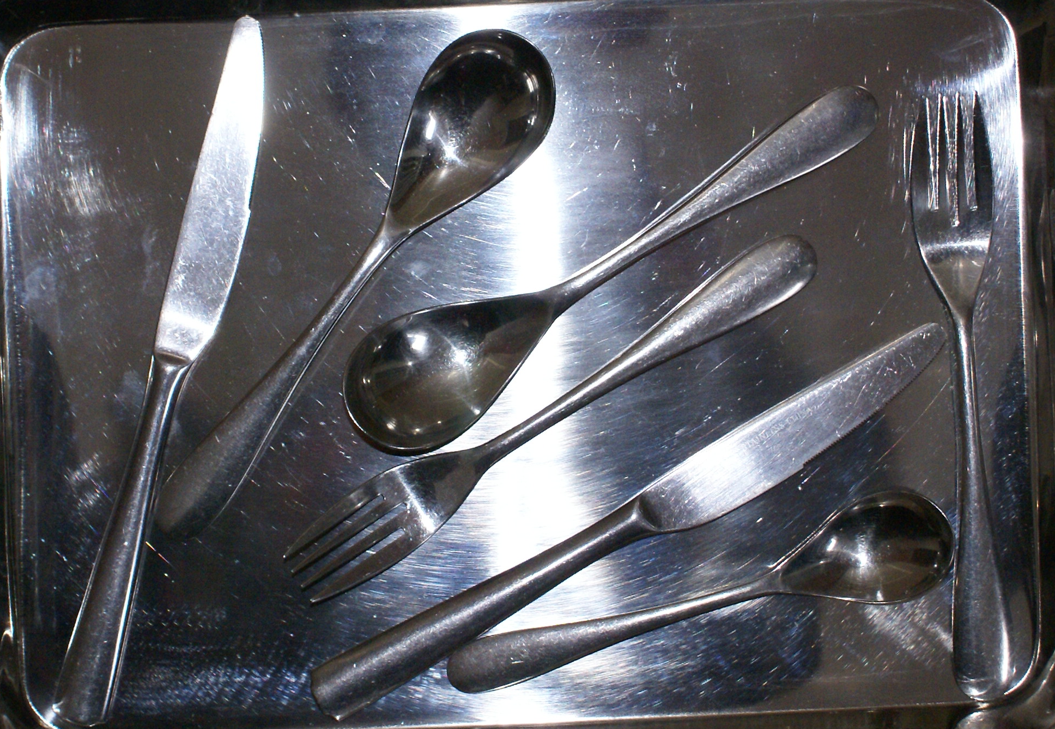

silverware stainless bg.png

Apply Canny filter using OpenCV:

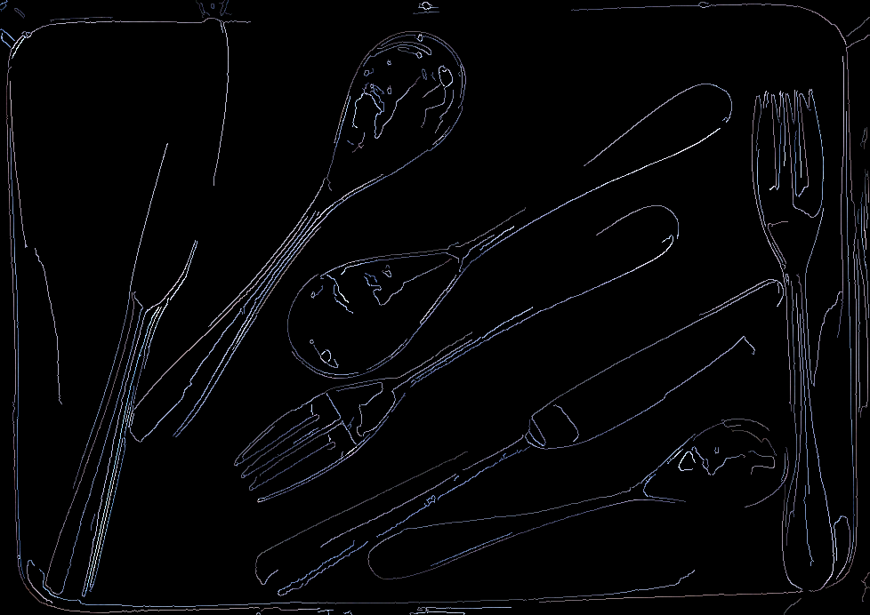

reflective_bg.png

Compare this image which has many false edges due to reflections to an image taken against a lime green paper background. Notice fewer reflections and better edges:

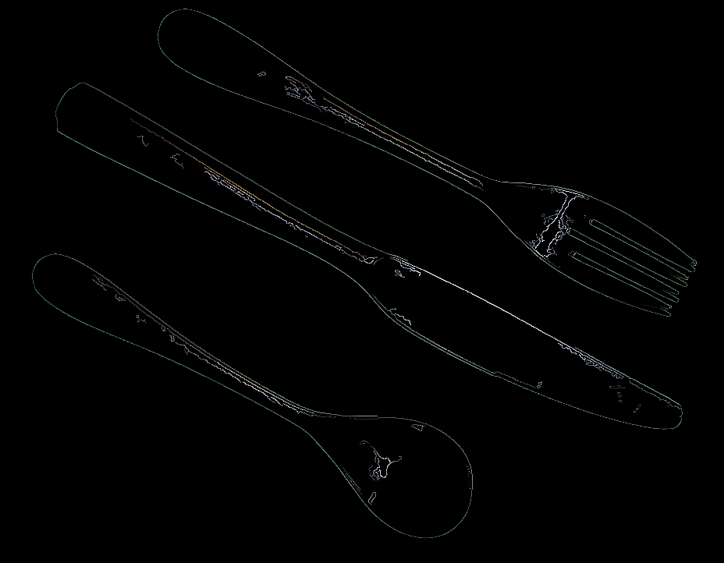

canny_nonreflective_bg.png